**Test Cases for OTP Verification System – Python Capstone Project**  
**Name: Sanjiban Hati  
Student ID: S8895**  
  
**Test Case1: Correct OTP inserted**  
  
When the OTP inserted by the user is similar as the OTP generated on the system, the user will get a message stating ‘OTP verified successfully. Access granted’.   
  
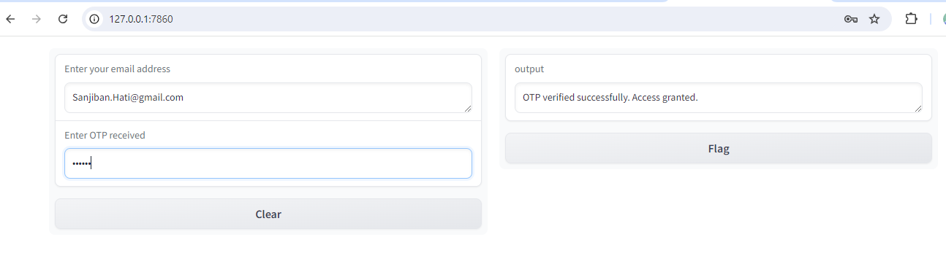  
  
**Test Case 2: Incorrect OTP inserted**  
  
when the OTP inserted by the user consists of 6 digits but is not similar to the OTP generated on the system, the user will get a message stating ‘Incorrect OTP. Access denied’.   
  
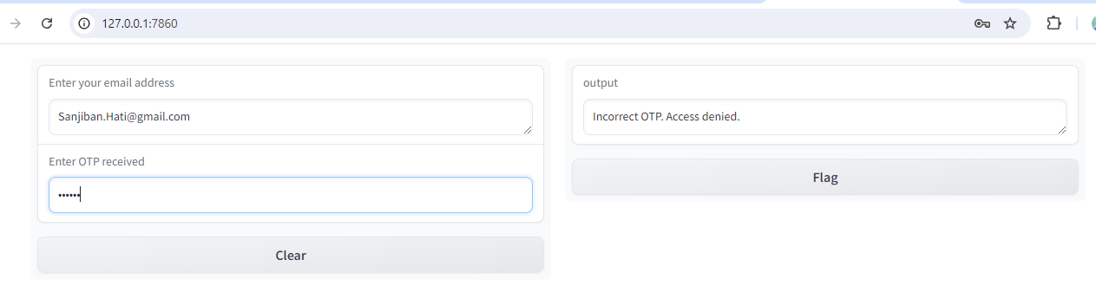  
  
**Test Case 3: Invalid OTP format**

In case the OTP inserted by the user has more or less number of digits other than six, the user will be prompted with the message ‘Invalid OTP format. Please enter a 6-digit OTP’.   
  
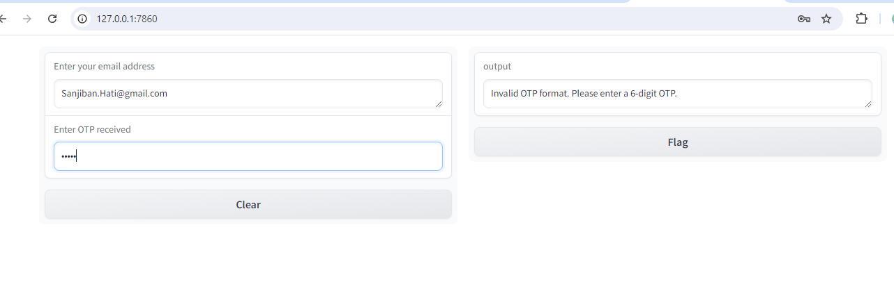

**Test Case 4: Invalid User Email**

In case the email address inserted by the user is not a correct email format, the user would be notified with a message stating ‘Invalid email address format. Please check the email and try again’.

